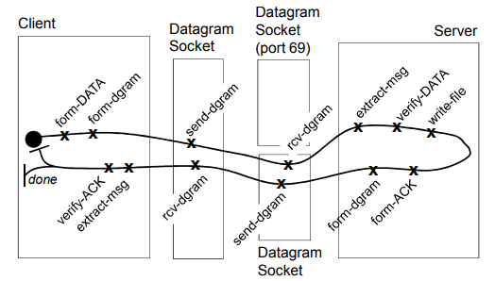

Read File Transfer

|  |  |  |
| --- | --- | --- |
| C1: Form DATA packet  C2: Form UDP Datagram w/ TFTP DATA Packet  C3: Extract UDP Datagram  C4: Verify ACK TFTP Packet  C5: Print - Done | E1: Send UDP Datagram E-Sim to Server  E2: Receive UDP Datagram  E3: Send UDP Datagram E-Sim to Client  E4: Receive UDP Datagram | S1: Extract UDP Datagram  S2: Verify DATA TFTP Packet  S3: Write File  S4: Form TFTP ACK  S5: Form UDP Datagram |

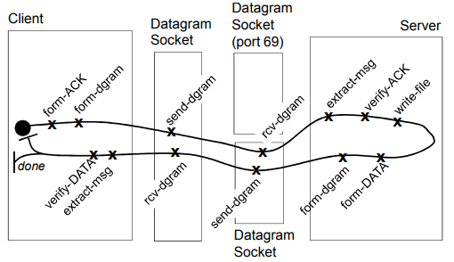

Write File Transfer

|  |  |  |
| --- | --- | --- |
| C1: Form ACK packet request  C2: Form UDP Datagram w/ TFTP DATA Packet  C3: Extract UDP Datagram  C4: Verify DATA TFTP Packet  C5: Print - Done | E1: Send UDP Datagram E-Sim to Server  E2: Receive UDP Datagram  E3: Send UDP Datagram E-Sim to Client  E4: Receive UDP Datagram | S1: Extract UDP Datagram  S2: Verify ACK TFTP Packet  S3: Write File  S4: Form TFTP DATA  S5: Form UDP Datagram |